Directions to Washington Lake Park
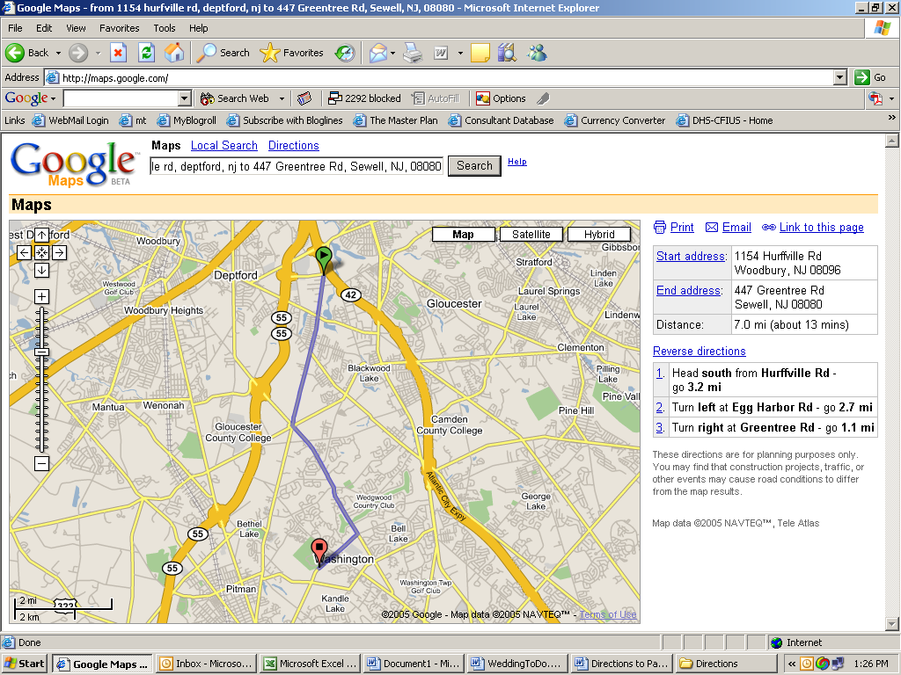 | = Fairfield Inn/Residence Inn  = Washington Lake Park  From Residence Inn/Fairfield Inn**  1. Turn right out of hotel parking lot, head south from Hurffville Rd (go 3.2 mi)  2. Turn left at Egg Harbor Rd (go 2.7 mi)  3. Turn right at Greentree Rd (go 1.0 mi)  4. Turn right into Washington Lake Park  Trip time: About 15 mins  At the Park  Park in Lot I (the first lot on the right after turning off of Greentree Rd). We’ll be playing softball on the field at the end of the parking lot, and will be having brunch at the pavilion just beyond the ball field. Make sure you bring the kids—there’s a playground and bathrooms, too!
**You can get directions to Washington Lake Park from any starting point by using your favorite mapping website, and entering 447 Greentree Rd, Sewell, NJ, 08080 as your destination address.

